MS-Word template for manuscript preparation for Intl. Jour. of the JSRM
- Subtitle with hyphens if necessary - (“title” tag)
Rocky MASSEY^{a,b,}*, George CLAY^{b} & Sandy STONEª (“author” tag)
a Member of ISRM: Dept. of Rock Mechanics, Faulty of Engineering, Rock University, Sakyo-ku, Kyoto 606-8501 Japan
b Dept. of Rock Mechanics, Faulty of Engineering, Rock University, Sakyo-ku, Kyoto 606-8501 Japan (“affiliation” tag)
Received dd mm yyyy; received in revised form dd mm yyyy; accepted dd mm yyyy (“received_date” tag)

Abstract (“heading_main” tag)
A manuscript should be prepared strictly according to the instructions set in this template document. The title, author(s), and affiliation(s) should be printed on the first page, followed by the abstract of 200–300 words, giving a brief account of the most relevant aspects of the article. Each article must include 5–10 keywords in order to indicate the main topics discussed in the article and to provide basic terms for indexing. Main text will start with one line spacing above. All figures and tables are positioned within text. The submitted manuscript should be classified into 7 categories and should have an appropriate number of pages for each category (i.e. Review: 8–12 pages, Research article: 8–12 pages, Express letter: 4–8 pages, Technical note: 6–12 pages, Summary: 2–4 pages and discussion: 2 pages or less). The uniform style could be ensured if the appropriate style tag is specified for each type of the paragraph by referring the type of style tag that is marked with red font at the end of the paragraph. (“abstract” tag)
Keywords: Rock mechanics, Research article, Guideline for manuscript, Instructions, Page proof, Template (“keywords” tag)

1. TEXT (“heading_main” tag)

1.1 General (“heading_sub” tag)
The article submitted to the International Journal of the Japanese Society for Rock Mechanics (JSRM), must be an original article involving new contributions to rock mechanics and its related fields, and it must be unpublished elsewhere in any language. (“text_main” tag)
Column margin 6mm
The manuscript of the article is to be sent to Committee on E-Journal, JSRM by email in the form of attached file, together with the prescribed submission form. Whole the process through manuscript submission, review & revision, acceptance, and final submission of the article, is conducted via only the Internet using email. Therefore the contributor must have a reliable email address for contact.
The text must be printed within the dimensions shown on these pages. Following the title, subtitle (if necessary), author(s), affiliation(s), received date, abstract, and key words, shown above, the main text should consist of two columns, each of which has 64 lines per page. Authors should pay attention to the correct format, clear figures, and proper references. The article information in the header and footer and received date will be filled in by the committee.

International Journal of the JSRM © 2024 by the Japanese Society for Rock Mechanics. This is an open access article licensed under CC BY-NC-ND 4.0. To view a copy of this license, visit https://creativecommons.org/licenses/by-nc-nd/4.0/
* Corresponding author. E-mail address: rocky.massey@xxxx.yy.jp (Rocky MASSEY)
Citation: Massey, R., Clay, G., & Stone, S., 2024. MS-Word template for manuscript preparation for Intl. Jour. of the JSRM, International Journal of the JSRM, 20, 240000, https://doi.org/10.11187/ijjsrm.240000.
Basically, use Times New Roman. Occasionally use Symbol. Never use any other fonts. The appropriate style tag should be specified for each type of the paragraph by referring the type of style tag that is marked with red font at the end of the paragraph. Never change the specifications of style tags in order to preserve the uniformity.

1.2 Head (title, authors, affiliations, received date, abstracts and keywords)
Title of article, author(s), affiliation(s), the heading “ABSTRACT”, 200-300 word abstract, and 5-10 keywords are printed in one column as shown on this page. Title should be in 14pt bold roman (no caps except for proper names), names of authors in 12pt roman (all caps for surname). Affiliations including mail address in 8pt italic and received date in 8pt roman (filled in by the committee) should be written underneath the names of authors. Asterisk marks should be put for each author. The heading “ABSTRACT” in 9pt bold roman, abstract in 9pt roman, and keywords in 9pt italics are to be printed next. Each paragraph except for the heading “ABSTRACT” must be specified by style tag with the same name. The heading “ABSTRACT” must be specified with “heading_main” tag.

1.3 Main body
Main body of text must be typed using roman 9pt size and 11pt line spacing. First lines of paragraphs are indented 5 mm (“text_main” tag) except for a few cases (“text_sub” tag: ex. paragraph underneath the equation). Type primary headings in caps 9pt bold roman (“heading_main” tag) and secondary headings in 9pt italics (“heading_sub” tags). Chemical elements etc. are exceptional.

2. Objects
Use SI unit systems in all texts, tables, and figures. Conventional units are sometimes allowed to use (Never mix the unit in the same manuscript.), for example, as
“min” and “h” instead of “s”
“deg” and “º” instead of “rad”
Use italic for variables except for mathematical functions such as “sin”, “grad”, etc. Superscripts and subscripts that are not variables should be in roman.

2.1 Equations
Use the equation editor of the selected word processing programme. Equations are placed on the left (“equation” tag). Number equations consecutively and place the number between parentheses with the tab key at the end of the line.
(“equation” tag)
$S_{c}=\frac{UCS}{2*[(\sqrt{\left(1+{(tanɸ)}^{2}\right)}+tanɸ}$ (1)
where UCS is the unconfined compressive strength. (“text_sub” tag)
When referring to equation in the text, use “Equation (1)” or “Equations (1) and (2)”. Fraction in text should be written as “E / (1+ν)”.

2.2 Tables and figures
Tables and figures including photographs (no distinction between diagrams and photographs) must be placed in line with text (Display “Format Picture” Dialog box, select “Layout” tab, and choose “In line with text”), preferably on the same page as they are cited (“table” tag and “figure” tag, respectively). Legends, symbols (for variables), and unit following comma (,) should clearly be written along axes in the figures. Numbers are sequentially put for tables and figures. Caption of table should be typed in 9pt roman (“table_caption” tag), and be placed above the table. Similarly, Caption of figure should be typed in 9pt roman (“figure_caption” tag) and be placed underneath the figure. When referring to figures in text, use “Figure 1” or “Figures 2 and 3”.
Table 1. Mechanical properties of test specimen. (“table_caption” tag)
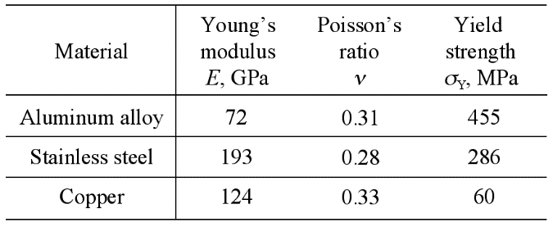(“table” tag)
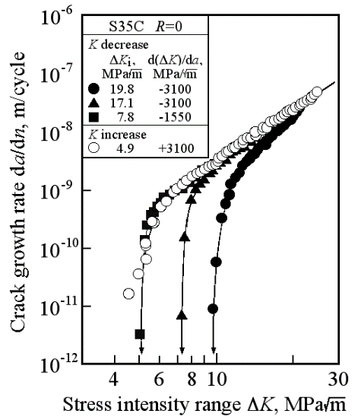(“figure” tag)
Figure 1. Relation between da/dn and ΔK. (“figure_caption” tag)

3. Other remarks
In the text, place the authors’ last names (without initials) and the date of publication in parentheses. At the end of the paper, list all references in alphabetical order (“reference” tag) underneath the heading “REFERENCES” (“heading_main” tag). If several works by the same author are cited, entries should be chronological. Full reference should clearly be written in English (even if it is a domestic journal) as shown in the following example.

AcknowledgementS
(if available) The rock core samples used in this study were provided by ????. The authors gratefully acknowledge the technical support provided by Abc Defg and Hij Klmn in XXXX University. This work was partially supported by JSPS KAKENHI Grant Number ????????.

References
Last name, First name’s Initial (ed.), year. Book title, City, Publisher. (“reference” tag)
Last name, First name’s Initial, year. Title of article, Title of Journal, volume number, (series number if necessary), page numbers or paper number, (if available) https://doi.org/10.11187/ijjsrm.******.
Massey, R., Clay, G., & Stone, S., 2024. MS-Word template for manuscript preparation for Intl. Jour. of the JSRM, International Journal of the JSRM, 20, 240000, https://doi.org/10.11187/ijjsrm.240000.

